**Advance**

**The purpose of the experiment:**

Assemble the Smart Car according to the instructions and install two 14500 rechargeable li batteries. Wire the drawing at the end of the article and upload the program advance.ino. Turn on the power switch at the rear of the Smart Car, and the Smart Car pauses for 0.5 seconds before starting.

**List of components required for the experiment:**

Arduino Smart Car *1

USB cable *1

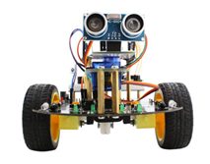       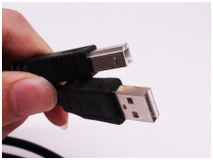

**Experimental code analysis:**

int Left_motor_back=9;      //IN1

int Left_motor_go=5;        //IN2

int Right_motor_go=6;       // IN3

int Right_motor_back=10;    //IN4

void setup()

{

  //Initialize the motor drive IO for output mode

  pinMode(Left_motor_go,OUTPUT); // PIN 5 (PWM)

  pinMode(Left_motor_back,OUTPUT); // PIN 9 (PWM)

  pinMode(Right_motor_go,OUTPUT);// PIN 6 (PWM)

  pinMode(Right_motor_back,OUTPUT);// PIN 10 (PWM)

}

void run(int time)

{

  digitalWrite(Right_motor_go,HIGH);

  digitalWrite(Right_motor_back,LOW);

  analogWrite(Right_motor_go,200);//PWM ratio 0~255 speed control,

                                 //the difference of left and right wheel slightly increase or decrease

  analogWrite(Right_motor_back,0);

  digitalWrite(Left_motor_go,HIGH);

  digitalWrite(Left_motor_back,LOW);

  analogWrite(Left_motor_go,200);//PWM ratio 0~255 speed control,

                                 //the difference of left and right wheel slightly increase or decrease

  analogWrite(Left_motor_back,0);

  delay(time * 100);   //execution time, can be adjusted

}

void loop()

{

  delay(500);

  run(10);

}

**Experimental steps:**

1. We need to open the code of this experiment: **advance.ino**, click“**√**” under the menu bar to compile the code, and wait for the word "**Done compiling** " in the lower right corner, as shown in the figure below.

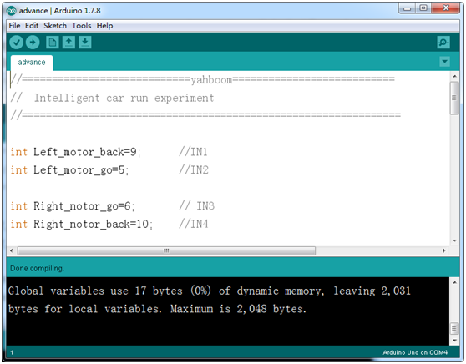

2. In the menu bar of Arduino IDE, we need to select 【Tools】---【Port】--- selecting the port that the serial number displayed by the device manager just now, as shown in the figure below.

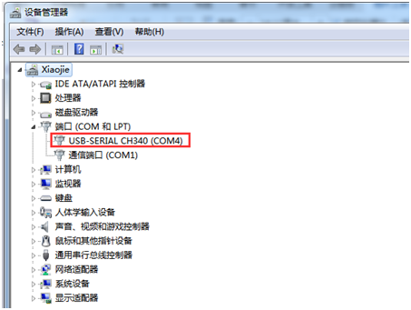

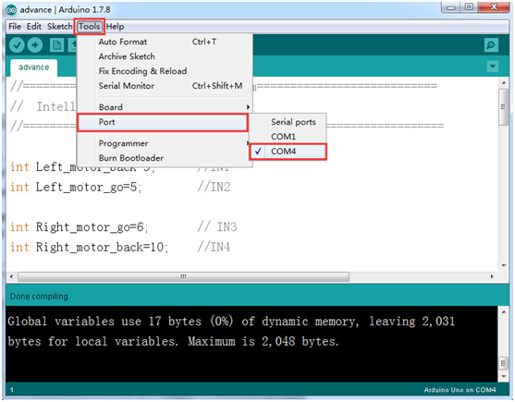

3.Click [Tools]---[Board]---Select Arduino Uno as shown below.

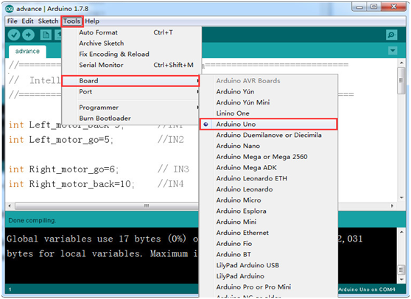

4.After the selection is completed, you need to click “**→**”under the menu bar to upload the code to the Arduino UNO board. When the word “**Done uploading**” appears in the lower left corner, the code has been successfully uploaded to the Arduino UNO board, as shown in the figure below.

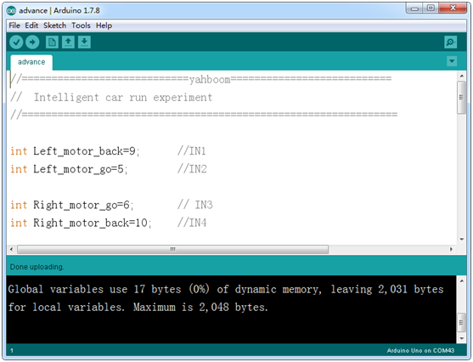

5. Please wire the Smart Car as shown below.

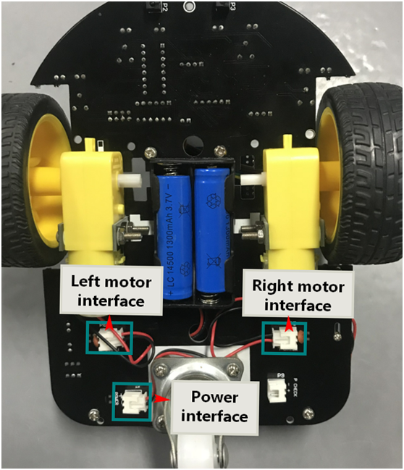

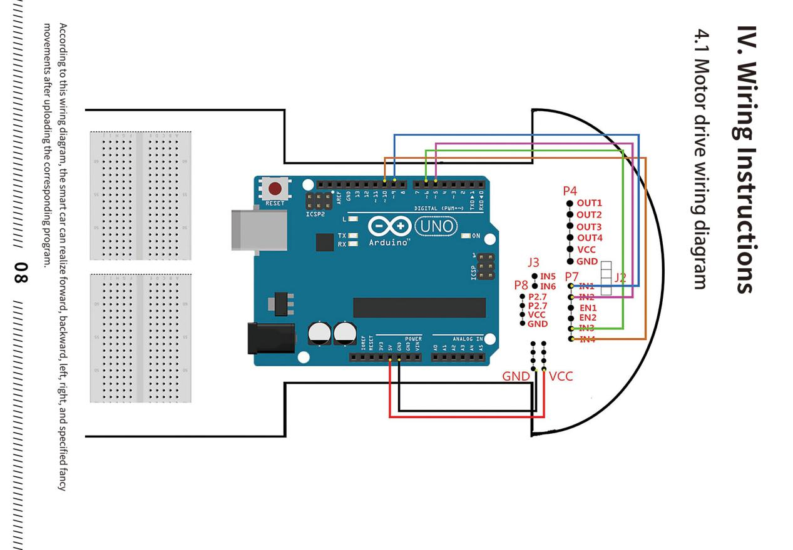

6. After the smart car is connected to the line and the program is uploaded, the power switch at the rear of the smart car is turned on, and the smart car stops after 0.5 seconds.

